

**State of Libya**

**Ministry of Education**

**Misurata University / Faculty of Science**

**………………. Department**

**Title**

Project submitted in partial fulfillment of requirements for the degree of Bachelor in……………………

Student name

Supervisor name

Semester



**State of Libya**

**Ministry of Education**

**Misurata University / Faculty of Science**

**………………. Department**

**Title**

Project submitted in partial fulfillment of requirements for the degree of Bachelor in……………………

Student name

Supervisor name

Semester

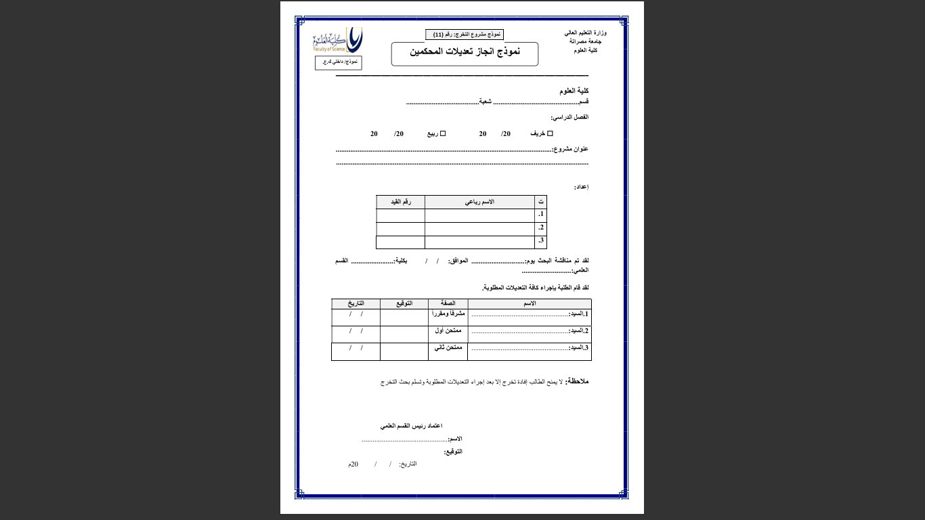

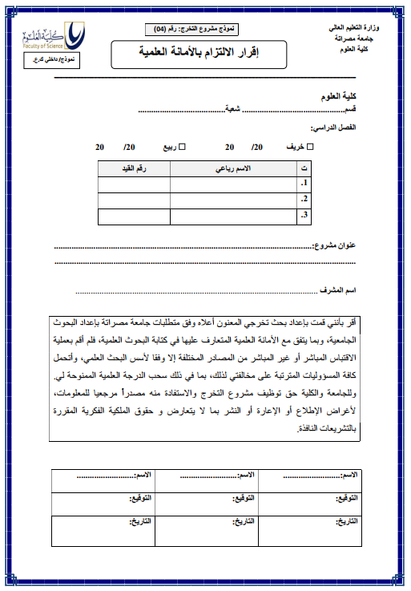

**بِسْمِ اللَّهِ الرَّحْمَنِ الرَّحِيمِ**

**﴿تكتب الاية القرآنية بالتشكيل﴾**

(سورة:....، الآية:.....)

# Dedication

The dedication should be written on a separate page and must not exceed one page in length.

Roman numerals (I, II, III,….) for the front matter (from the Quranic verse to the abstract)

Arabic numerals (1, 2, 3) for the body of the document, Starting from the introduction.

Margins

* Top, Bottom Margins : 2 cm
* Left Margin 3.5 cm
* Right Margin: 2.5 cm

Font: Times New Roman

Size: main heading 14 bold, subheading 13 bold, Body text 12

Line spacing: double-spaced formatting

# Acknowledgement

The Acknowledgment should be written on a separate page and must not exceed one page in length.

# Table of Contents

|  |  |  |
| --- | --- | --- |
| **S.N.** | **Contents** | **Page Number** |
| 1 | First main heading | 4 |
| 1.1 | First subheading | 4 |
| 1.1.1 | First sub-subheading | 4 |
| 1.1.2 | Second sub-subheading | 5 |

**OR** Use an automatic table of contents

Dedication II

Acknowledgement III

Table of Contents IV

List of Tables V

List of Figures VI

List of Abbreviations VII

Abstract…. VIII

1. Introduction……. 1

1.1. Aim of the Study.. 2

2. Literature Review… 3

3. Materials And Methods.. 4

3.1. Research Design… 4

3.2. Participants and Data Sets… 4

3.3. Data Collection and Instrumentation… 4

3.4. Data Analysis… 4

4. Results……. 5

4.1. Effect of………………… 5

5. Discussion…… 6

6. Conclusion….. 7

7. Recommendations…. 8

8. References…… 9

9. Appendices….. 10

10................ ...... الملخص 11

# List of Tables

|  |  |  |
| --- | --- | --- |
| **Table Number** | **Table Title** | **Page Number** |
| 1 | Title of the First Table | 7 |
| 2 | **Title of the Second Table** | 8 |
| 3 | **Title of the Third Table** | 9 |

# List of Figures

|  |  |  |
| --- | --- | --- |
| **Figure Number** | **Figure Title** | **Page Number** |
| 1 | Title of the First Figure | 7 |
| 2 | Title of the Second Figure | 8 |
| 3 | Title of the Third Figure | 9 |

# List of Abbreviations

|  |  |
| --- | --- |
| **Abbreviation** | **Full Form** |
| PDA | Potato Dextrose Agar |
| WHO | World Health Organization |

# Abstract

The abstract provides the reader with a clear overview of the graduation project's main points. The word limit for the abstract ranges between **250-300 words**.

# Introduction

It is recommended that the introduction does not exceed **30%** of the overall volume of the graduation project.

## Aim of the Study

# Literature Review

The review of literature is a thorough synthesis and analysis of literature related to the research topic.

# Materials and Methods

This chapter describes the plan for conducting the study. It explains what the researcher must do to collect data or conduct the experiment. You can divide it into subheadings, for example:

## Research Design

## Participants and Data Sets

## Data Collection and Instrumentation

## Data Analysis

# Results

The results use descriptive language, tables, and figures to present and display findings.

Figures, tables, and pictures are numbered in their own sequence. The table title is written above the table, while the figure title is written below the figure or picture.

## Effect of…………………

**Table1:** Effect…………….

|  |  |  |  |
| --- | --- | --- | --- |
| **Groups** |  |  |  |
| Control | Mean ± Standard Error |  |  |
|  |  |  |  |

**Figure 1:** Effect…………….

# Discussion

The Discussion will include, Interpretation of the significance of your results, A comparison of results with those in the literature. A discussion of the relevant literature. The student may also combine the results and discussion into one section titled **"Results and Discussion."**

# Conclusion

The conclusion should preferably not exceed one page.

# Recommendations

The recommendations in your graduation project are based on the conclusions drawn from your research.

# References

Use the reference style of the American Psychological Association (APA), 7th edition. Alternatively, use the reference style of the Institute of Electrical and Electronics Engineers (IEEE 2023) if permitted by your academic department.

References must be up to date (within the last 10 years), taking into account the specificity of some references.

# Appendices

An appendix should include supplementary material that supports your graduation project, such as raw data, questionnaires, detailed methodologies, statistical analysis tables, ethical approval, etc.

Each appendix must have **a descriptive title,** be numbered, and be referenced within the main text.

# الملخص

Write the abstract of the graduation project in Arabic.



**دولــــة ليـــبـــيا**

**وزارة التعليم العالي والبحث العلمي**

**جامعة مصراتة / كلية العلوم**

**قسم ..................(شعبة ......................)**

**العنوان باللغة العربية**

**العنوان باللغة الانجليزية**

قدم هذا البحث استكمالا لمتطلبات نيل درجة البكالوريوس في ..................

**إعداد**

يكتب الاسم الثلاثي للطلبة (مرتبة ابجديا)

**إشراف**

يكتب الاسم الثلاثي للمشرف

يكتب الفصل الدراسي